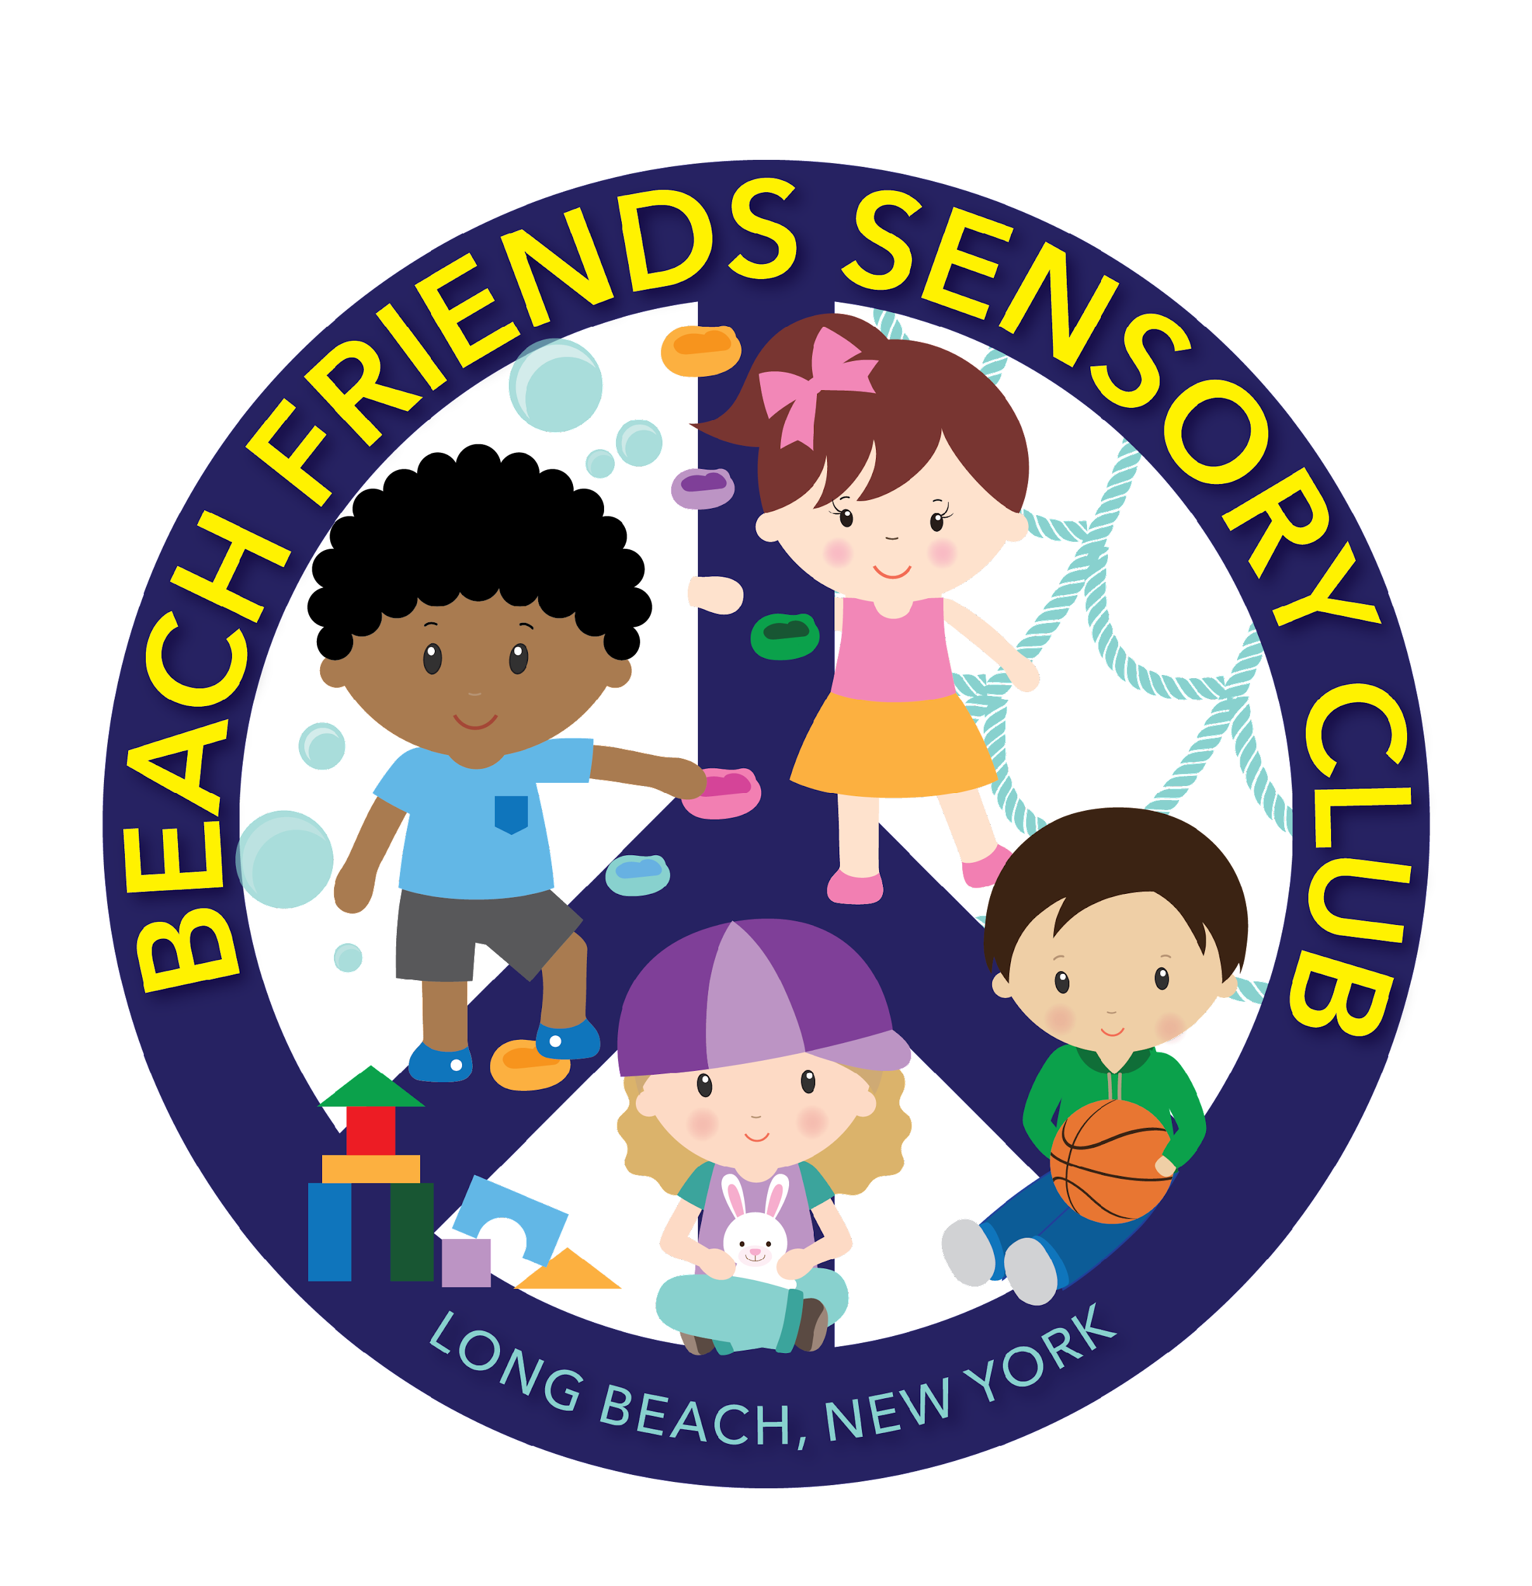

Beach Friends’ Operational Calendar
2024-2025
July - August 2024
Monday, July 8th: First Day of Summer Session (School Open)

Friday, August 23rd: Last Day of Summer Session (School Open)

September 2024- June 2025
Wednesday, September 4th: First Day of School (School Open)

Thursday, October 3rd & Friday, October 4th: Rosh Hashanah (School Closed)

Monday, October 14th: Columbus Day/Indigenous Peoples’ Day (School Closed)

Monday, November 11th: Veteran’s Day (School Closed)

Thursday, November 28th & Friday, November 29th: Thanksgiving Recess (School Closed)

*** Monday, December 23rd - Friday, January 5th: Holiday Recess (School Closed)
***Monday, January 6th Return from recess (School Open)***

Monday, January 20th: Martin Luther King, Jr. Day (School Closed)

*** Wednesday, January 29th: Lunar New Year (School Closed)

Monday, February 17th - Friday, February 21st: Winter Recess (School Closed)

Monday, April 14th - Monday, April 21st: Spring Recess (School Closed)

Monday, May 26th: Memorial Day (School Closed)

Wednesday, June 19th: Juneteenth (School Closed)

Wednesday, June 27th: Last Day of School (School Open)

Summer Session 2025
Monday, July 7th: First Day of Summer Session (School Open)

